**Arshdeep Singh Kawatra**

Thapar Institute of Engineering & Technology, Patiala, Punjab.

Ph: 9555564433

Email: arshskawatra@gmail.com

Covid-19 Solution Challenge

### Topic: An App for patient tracing, contact detection, patient follow up, lockdown support and determination of testing eligibility.

# Objective:

To develop and provide a technological solution that identifies potentially infected COVID-19 patients by contact tracing, provide a method to collect and monitor patient follow up data to study re-infection trends up to 6 months and to reduce panic amongst the population by providing methods to propagate correct and verified information.

# Solution

A cross platform app/webapp that solicits the active support of **ordinary citizens as** **corona warriors** by providing the following features:

1. **Contact Tracing:** Provides a verified list of infected/quarantined COVID-19 subjects sourced from the Ministry of Health & Family Welfare to the users. Users of the app can browse through this list and can search by name, address, city, state and pin code for people who have been infected or are under quarantine for COVID-19 (Fig 1). If the user has been in contact with any patient in the list, he/she can choose to mark ‘yes’ in the provided checkbox and the app guides the user to check the need for testing as per ICMR guidelines (Fig 2) or self-quarantine. MoHFW can hence identify and trace people who have been in contact with a subject that has been tested positive and thus efficiently recognize and mitigate clusters.
2. **Follow up for Cured Patients:** It is extremely important to monitor patient health after he/she is deemed to be cured to monitor re-occurrence. The health of cured patients can be tracked using the app. For the first 15 days after a patient is deemed as cured, he/she is required to update his/her vitals once every day on the app (Fig 3). The patient will be reminded of the same using notifications on his/her phone. After the 15 day period, the patient will be reminded once every month to update his vitals on the app which can be analyzed to determine his/her health status to monitor and analyze recurrence of the disease in a cured patient.
3. **Advisory Screen:** The advisory screen consists of a regularly updated feed of advisories, guidelines and updates pushed by the MoHFW itself (Fig 4). This allows users to view and educate themselves with trusted, verified information from the government about COVID-19, preventing spread of fake news and giving the MoHFW a platform to communicate with the population.
4. **Testing Eligibility Screen:** This screen provides a form to the user (contact or non-contact) (Fig 2). The form consists of the requirements provided by MoHFW for being eligible for testing for COVID-19. On filling the form, if the user has symptoms as per the testing requirements, the MoHFW will be notified about the patient details and testing can be arranged accordingly for the user after being certified by a doctor.
5. **COVID-19 Tracker:** This screen provides detailed data about the number of cases in the country state wise along with hotspots and statistics like growth/decrease in cases in percent, etc. as updated by the MoHFW (fig 5).

# Specifications

* + - 1. Even though ethicality of the method of contact tracing by releasing data of infected patients to the public is debatable, it is a step that the MoHFW needs to take, as given the magnitude of the situation, this is the quickest way to create a database of potential victims of the disease and prevent cluster outbreaks.
      2. The form for follow up of cured patients can be modified according to recommendations of ICMR based on research regarding the frequency of reminder notifications and the details of vitals collected from the user.
      3. The advisory screen can be customized to provide any kind of information the MoHFW desires to convey to the public be it announcements, guidelines, training sessions, quarantine details, etc.
      4. The COVID-19 tracker screen can be used to create a full dashboard containing data about the disease so that the public is always aware about the situation and its intensity.

# Prototype

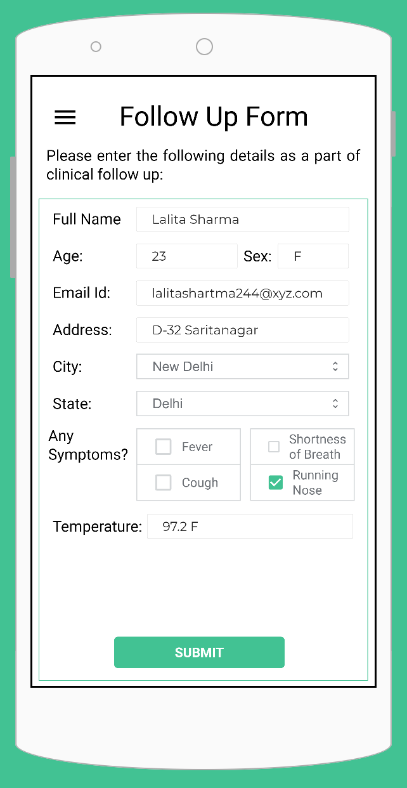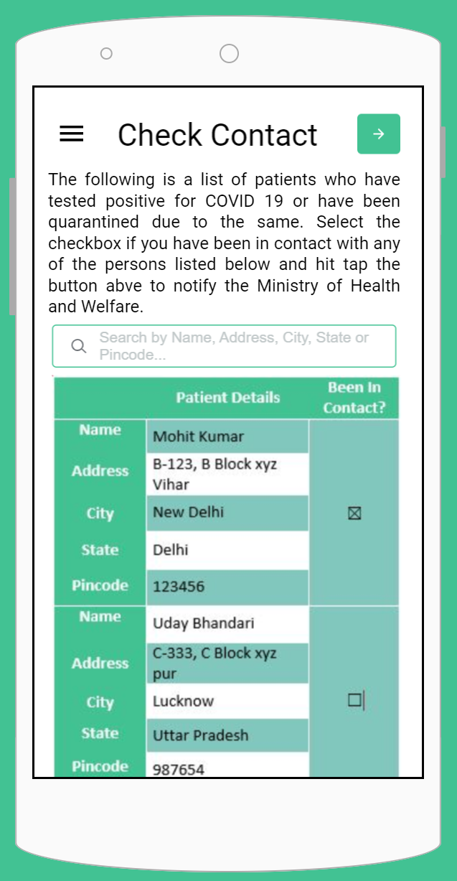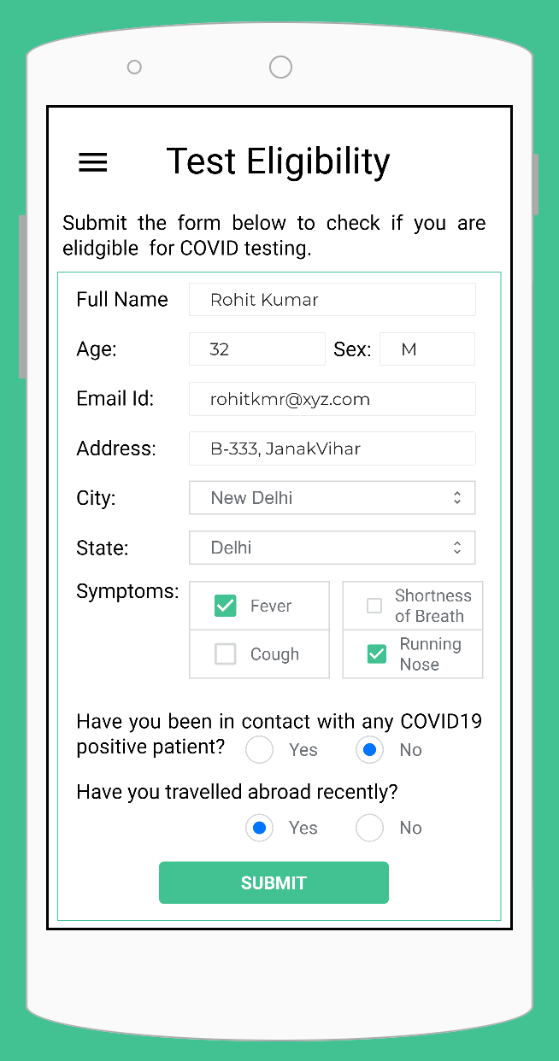

Fig 1 Fig 2 Fig 3

Fig 4 (App Home) Fig 5 Fig 6

